ComicCraftAI
AI-Powered Comic Story Creator
Using Gemini Models
Project Documentation

Team Leader : K. Bathul Sana
Team Members : H. Atiyah Fathima,
M. Ayisha Afrin,
N. Aysha Siddika.

Department: Department of Computer Applications
Programme: Bachelor of Computer Applications (BCA)
College: Chevalier T. Thomas Elizabeth College for Women, Perambur, Chennai - 600011

1. Project Overview
ComicCraftAI is an AI-powered web application designed to transform a simple story idea into a structured comic.
The user provides a story concept along with details such as the main character, setting, tone, and art style. ComicCraftAI then develops the idea into a five-panel comic, generates the story content and illustrations, presents the completed comic through a web interface, and allows the result to be exported as a PDF.
The main idea behind the project is to make comic creation easier for people who may have a creative idea but do not have advanced skills in story writing, illustration, or comic design.
Our implementation combines AI-based text generation with image generation and a Python-based web application to create an end-to-end creative workflow.
2. Problem / Need for the Project
Creating a comic traditionally involves several separate tasks:
- Developing a story
- Dividing the story into scenes
- Writing narration and dialogue
- Designing characters and scenes
- Creating illustrations
- Arranging the panels
- Preparing the final comic for sharing or printing
For beginners, managing all these stages can be time-consuming and technically difficult.
ComicCraftAI addresses this by bringing these stages together into one workflow. Instead of starting with a blank page and creating everything manually, the user can begin with a simple idea and allow the application to assist with the creative development.
3. Objectives
The main objectives of ComicCraftAI are:
- To convert a simple user idea into a structured comic story.
- To organize the story into five connected panels.
- To generate narration and dialogue suitable for each panel.
- To create AI-generated illustrations based on the individual scenes.
- To provide customization through character, setting, tone, and art style.
- To display the generated comic through an easy-to-use web interface.
- To combine the generated content into a downloadable PDF.
- To demonstrate how different AI services can be integrated into a single application

4. How ComicCraftAI Works

The application follows this overall workflow:
User Idea
↓
Story Outline Generation
↓
Story & Dialogue Generation
↓
Panel Image Generation
↓
Comic Layout Construction
↓
Comic Preview
↓
PDF Export
The system separates the creative process into stages instead of asking one AI model to perform everything at once.

5. Key Features
✦ AI Story Generation
✦ Five-Panel Story Structure
✦ Customizable Story Inputs
✦ AI-Generated Illustrations
✦ Integrated Comic Preview
✦ PDF Export

6. Technology Stack
Python , FastAPI , Jinja2 , Google Gemini , Hugging Face Interface , Pillow , FPDF2 , HTML & CSS , Git & GitHub , VS Code

7. System Architecture
ComicCraftAI is organized into separate modules so that each major task has a clear responsibility.
Overall Architecture
USER
│
▼
Web Interface
│
▼
FastAPI Backend
│
┌─────────┴─────────┐
▼ ▼
Story Generation Image Generation
│ │
Gemini AI Hugging Face
/ Gemini Image
└─────────┬─────────┘
▼
Comic Layout
│
▼
PDF Export
- Project Structure
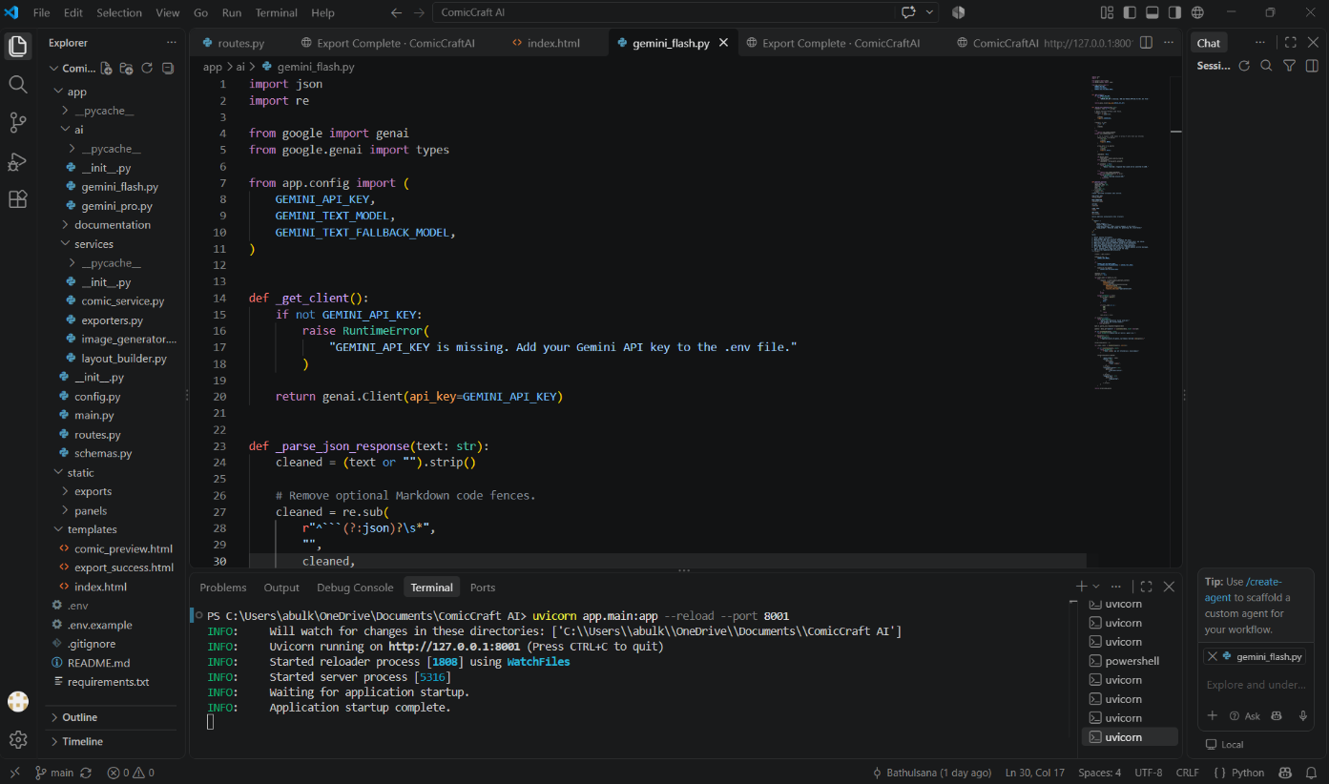

- Web Interface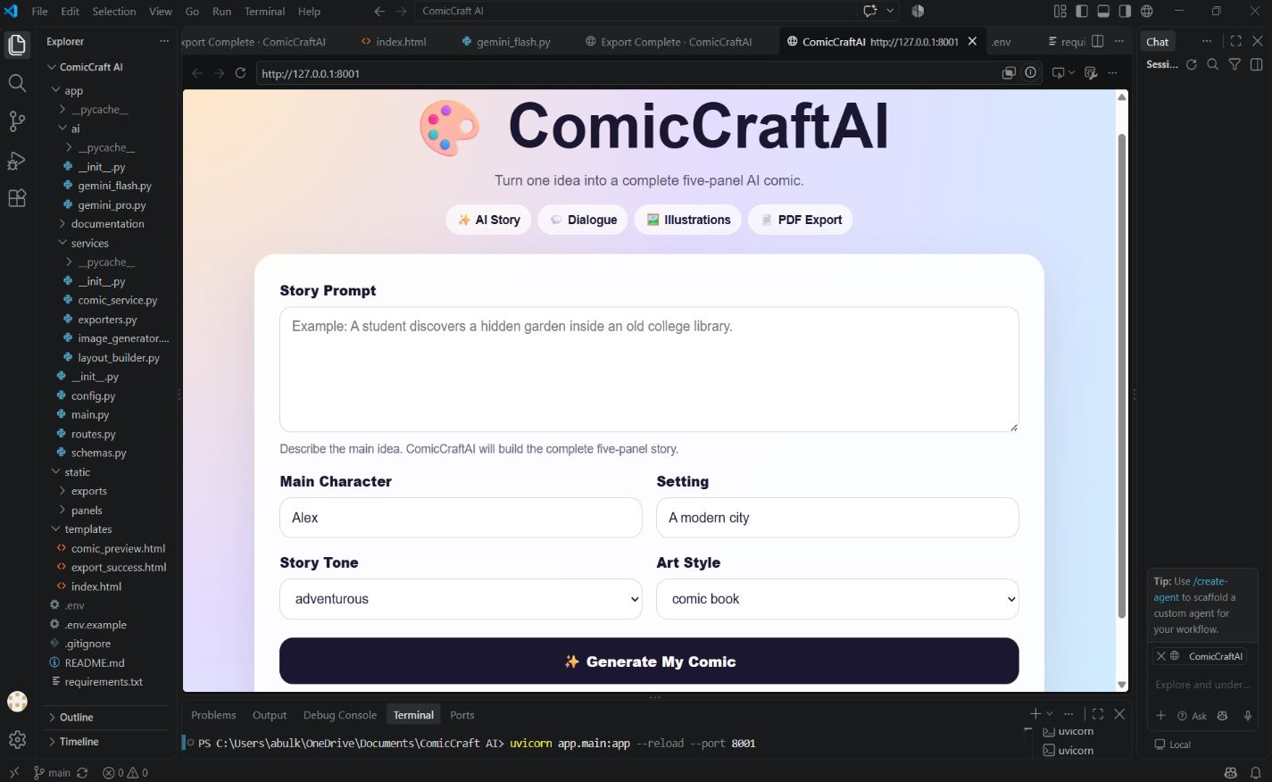

10.Final Outcome
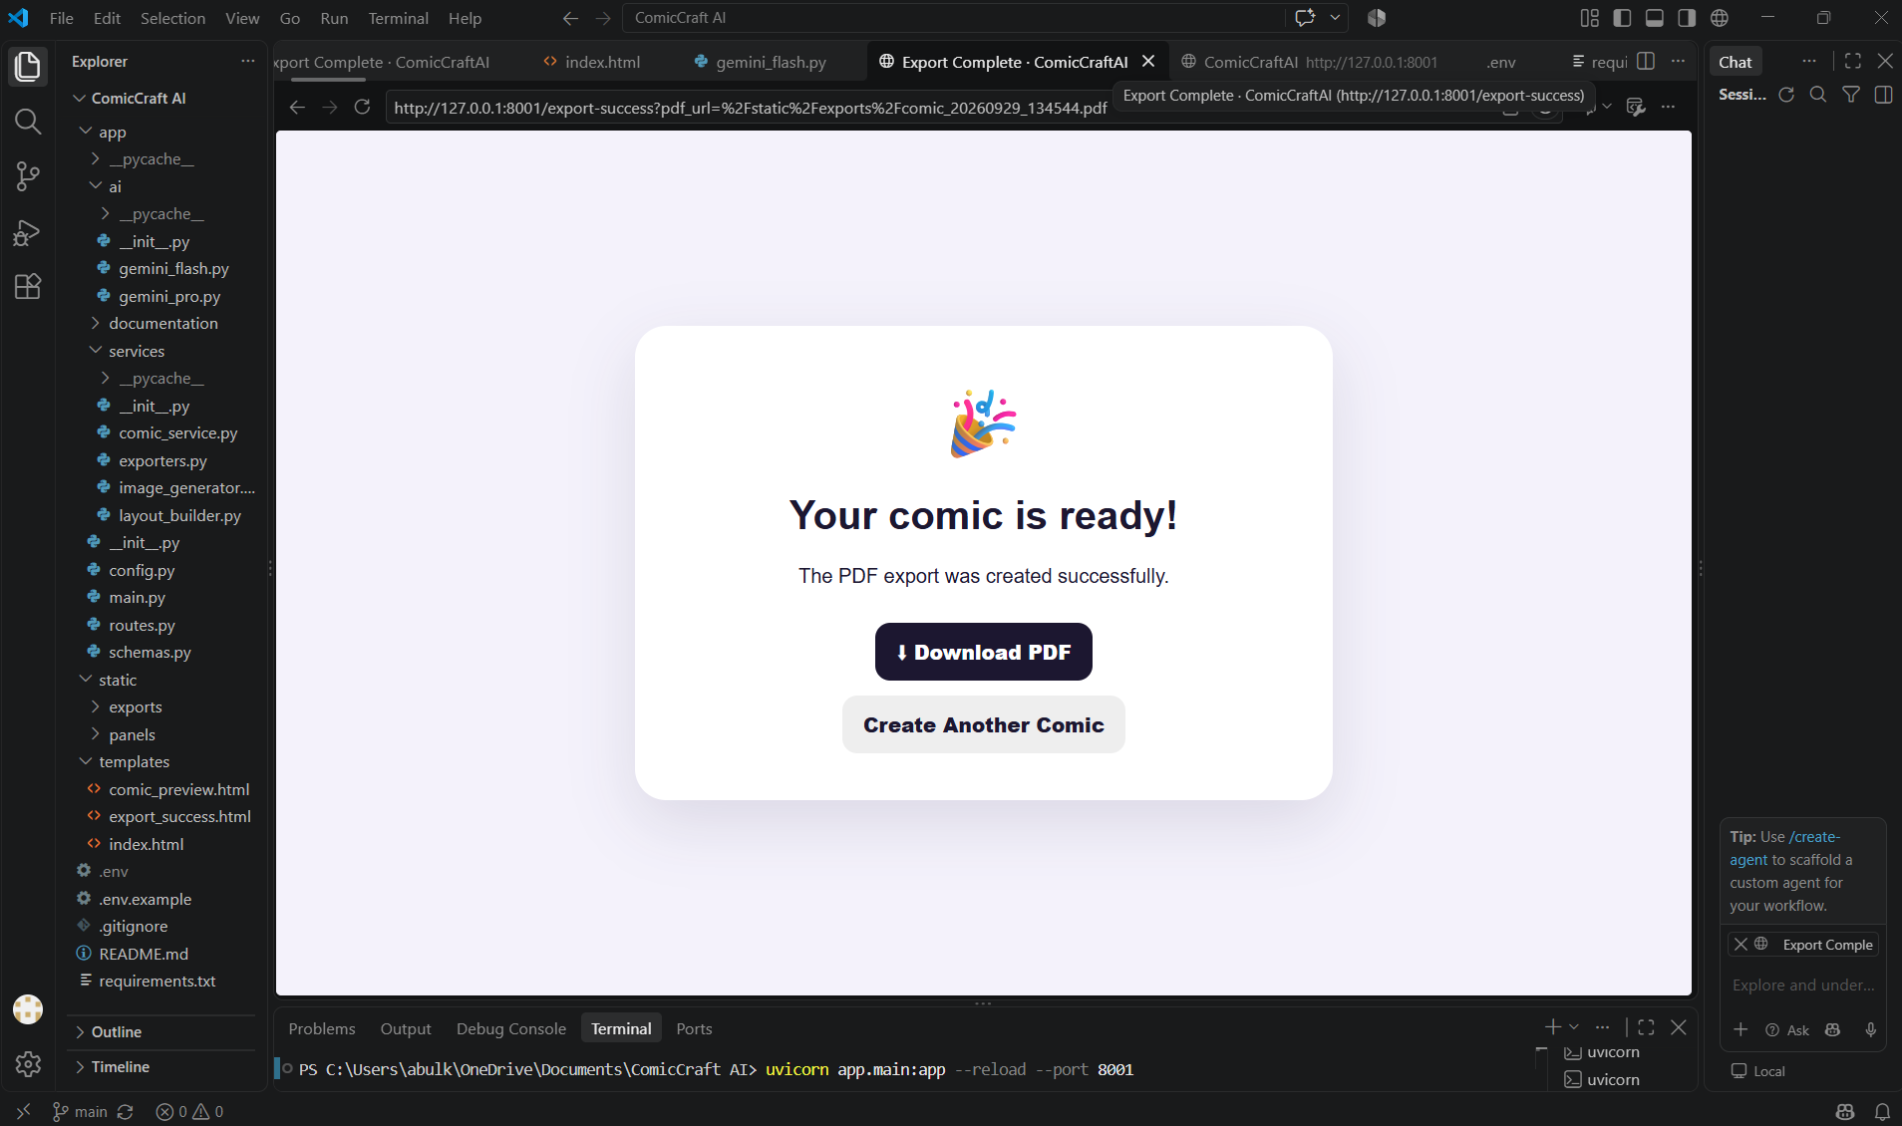

The Completed Comic can also be exported as a PDF.
11.Major Project Modules
gemini_flash.py
Responsible for creating the initial five-panel story outline.
It takes the user's story idea and produces structured information for each panel, including the title, scene description and image prompt.
gemini_pro.py
Develops the outline into the actual comic narrative, including captions, narration and dialogue.
image_generator.py
Creates the visual artwork for each panel using the generated image prompts.
Our implementation uses hosted AI inference rather than requiring the user to install a large local image-generation model.
comic_service.py
Acts as the main workflow coordinator.
It connects the individual stages.
This is important because the modules do not work as isolated features; this service connects them into one complete comic-generation pipeline.
layout_builder.py
Combines the generated story information and image paths into a structured panel layout.
exporters.py
Creates the final PDF from the completed comic layout.
12. Working Demonstration — Sana Story
For our demonstration, we used the following input:
Story Prompt
“A girl is walking on the road and there she saw a old woman. She helped that old woman to cross the road. That old woman thanked her and gave her a bag full of apples. The Girl happily returned home.”
Input Details :-
Main Character: Sana
Setting: A Modern City
Tone: Heartwarming
Art Style: Comic book
From this single idea, ComicCraftAI generated a five-panel storyline, developed the narrative and dialogue, generated illustrations for the scenes, and combined the results into a comic that could be previewed and exported as a PDF

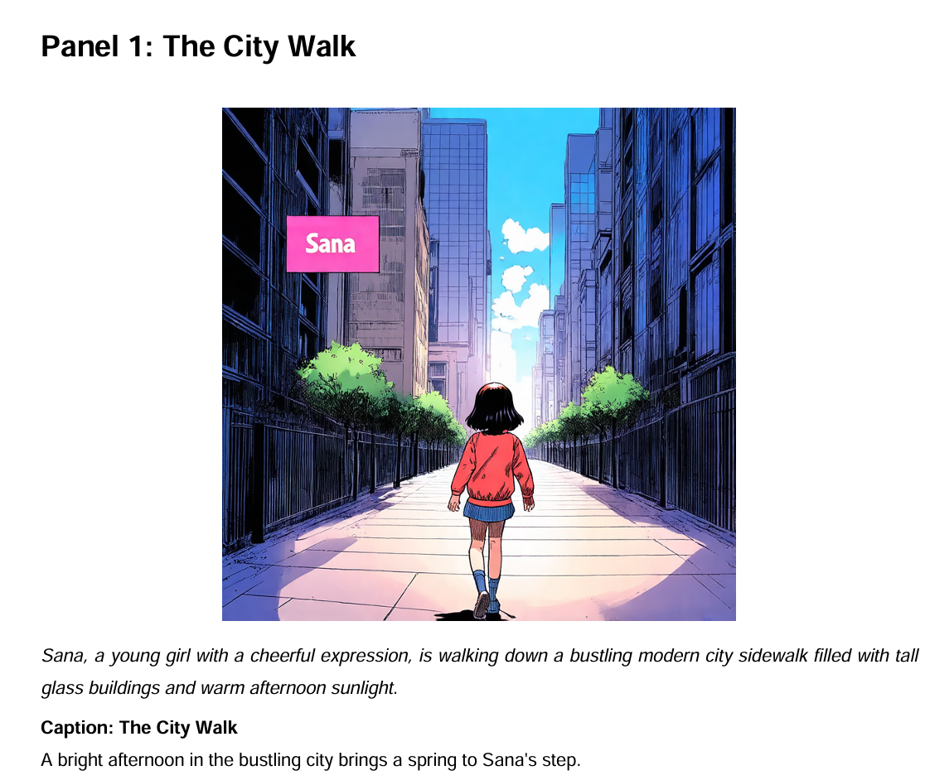
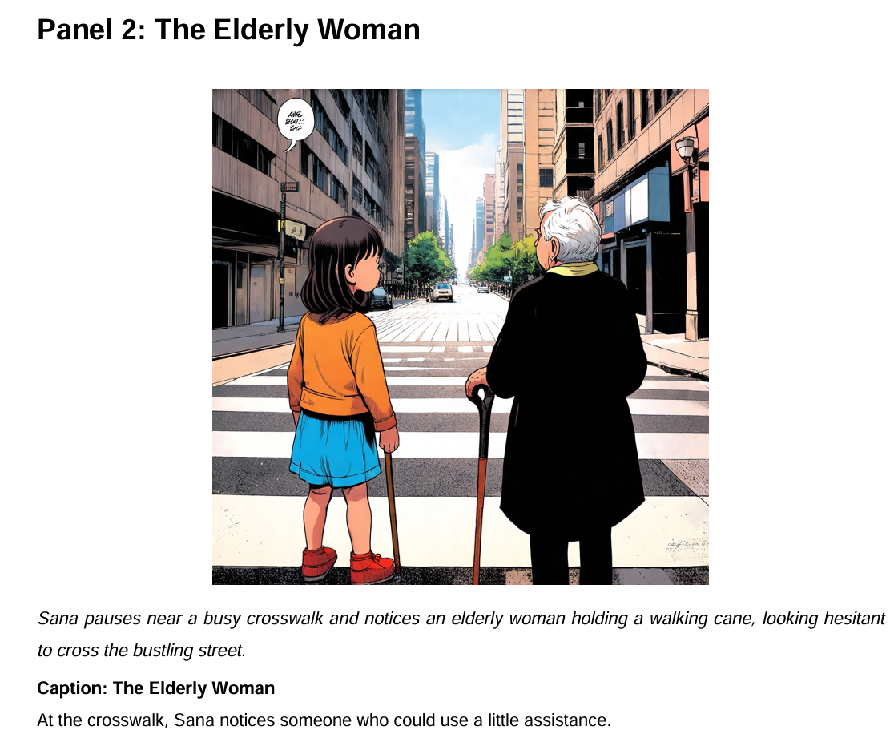

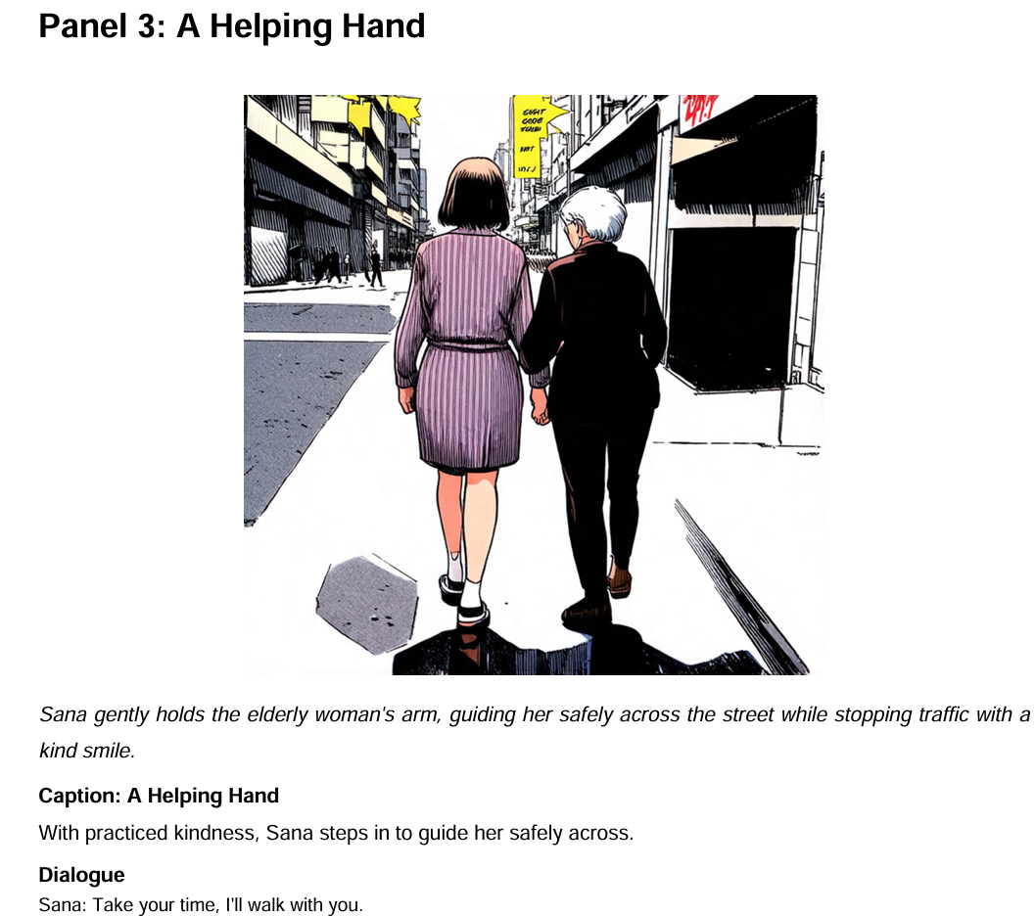
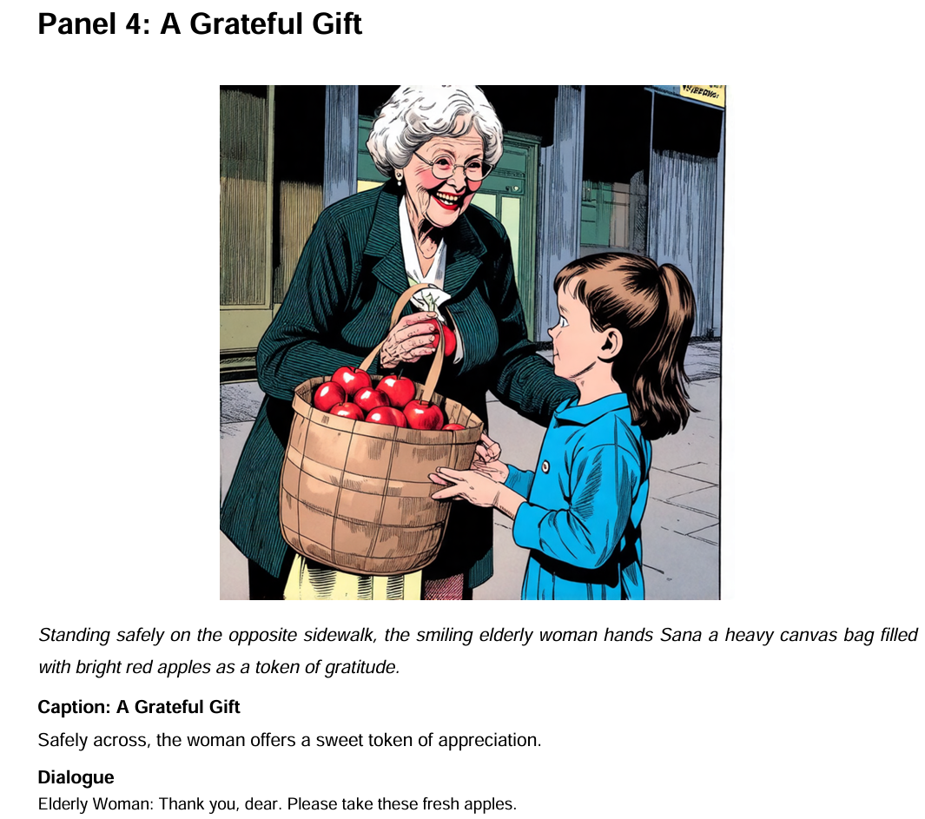
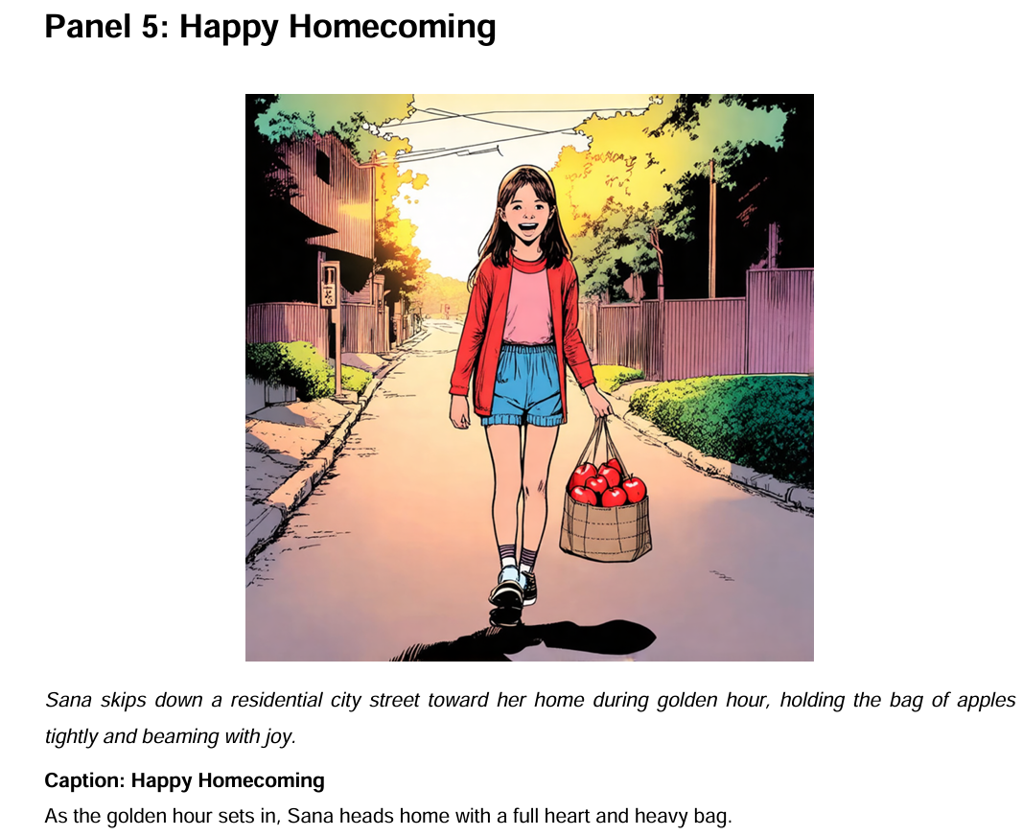
13. Benefits
- Makes comic creation easier for beginners.
- Reduces the time required for story planning and visual creation.
- Combines text generation and image generation in one workflow.
- Allows users to customize the character, setting, tone and art style.
- Produces a structured five-panel comic rather than isolated AI-generated images.
- Provides a downloadable PDF that can be saved or shared.

14. Future Enhancements
Possible future improvements include:

🎨 Better Character Consistency
- A character-reference system could help maintain the same appearance across every panel.

🖼️ Custom Panel Layouts
- Users could choose different comic layouts instead of having one fixed arrangement.

💬 Automatic Speech Bubbles
- Dialogue could be placed directly into speech bubbles within the artwork.

🌐 Multiple Language Support
- Users could create comics in different languages.

✏️ Panel Editing
- Users could regenerate or edit an individual panel without generating the entire comic again.

📚 More Export Options
- Additional formats such as image collections or presentation-ready files could be supported.

☁️ Online Deployment
- The application could be deployed online so users can access it without setting up the development environment locally.

15. Conclusion

ComicCraftAI demonstrates how generative AI can be integrated into a complete creative application rather than being used only as a standalone chatbot or image generator.
The project takes a simple story idea and processes it through multiple stages—story planning, narrative generation, image generation, layout construction and PDF export—to produce a complete comic.
Through this project, we explored the practical integration of AI services with a Python web application and learned how different software components can work together as one workflow.
Our aim was to make the process simple for the user while keeping the underlying workflow structured and modular.

16. Team Details
Project Team:
Team Leader : K. Bathul Sana
Team Members : H. Atiyah Fathima,
M. Ayisha Afrin,
N. Aysha Siddika.
Programme: Bachelor of Computer Applications (BCA)
Department: Department of Computer Applications
College: Chevalier T. Thomas Elizabeth College for Women

17. GitHub Repository
The source code and project files are maintained in our GitHub repository:
ComicCraftAI — GitHub Repository
View GitHub Repository :
https://github.com/Bathulsana/ComicCraftAI
The repository contains the application's source code, templates, configuration examples, requirements and project documentation.
.

